Hope For Appalachia
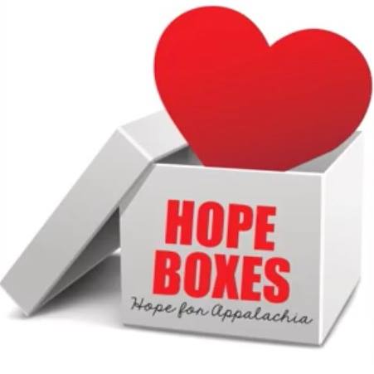
Basic Items In Each Box

PK to 2nd Grade 3rd to 5th Grade 6th – 8th Grade
Toothpaste Toothpaste Toothpaste
Toothbrush Toothbrush Toothbrush
Socks - Medium Socks - Large Socks –mens/womens
Comb/Brush Comb/Brush Comb/Brush
Chapstick Chapstick Chapstick
Pencils Pencils Pencils
Sharpeners Sharpeners Sharpeners
Erasers Erasers Erasers
Crayons Crayons Colored Pencils
Markers Markers Ballpoint pens
Glue Sticks Elmers Glue Highlighters
Character Bodywash Character Bodywash Deodorant
Hair bows/Ties Hair bows/Ties Hair bows/Ties
Small Toys Small Toys Small notebook

Please do not include the following items in the boxes: bar soap, washcloths, water guns or any type of gun, any food products or any liquids. Thank you!

